Rogue River Fisheries Restoration
Submitted as a 2020 Infrastructure Project
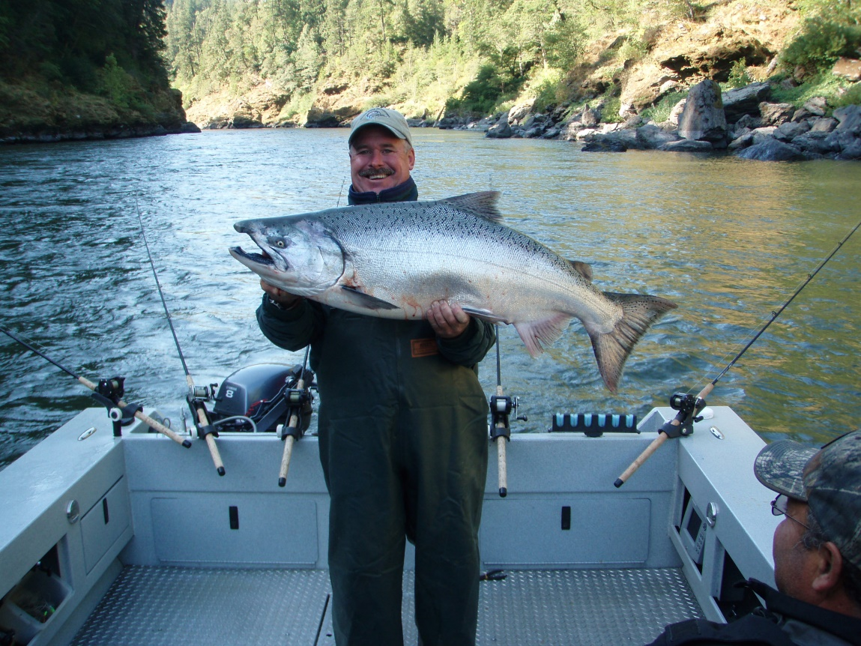
Rogue River Wild Spring Chinook have declined 60%
Hatchery Spring Chinook returns are down 63% over 15 years
(down 77% over last 4 years)
“On the fact that any flood control plan detrimental to the fishery resource would be unacceptable, both locally and to the Federal and State fishery agencies”.
From Final Environmental Impact Statement for Lost Creek Lake Project May 1972
House Document 566 used for authorization of Rogue Basin Project assumes responsibility all impacts of the project.
Fishery Facilities: “The projects proposed herein include provisions for construction and operation of facilities for enhancement of fish and wildlife resources of the basin and for mitigation of and restitution for losses occasioned by project construction”.
December 2019
Executive Summary December 12, 2019
Rogue River Basin Restoration and Restitution of Fisheries project for 2020 $274.2 million
The Rogue River Spring Chinook fishery was once a jewel of spring time fisheries on the west coast, returning 34,000 top quality Spring Chinook Salmon. Only a very few rivers have a Spring Chinook run. Now the famous Rogue River Spring Chinook runs are extremely depressed. In 1977 Lost Creek Dam was completed 157 mile upriver from the ocean. There was 11 miles of Spring Chinook spawning habitat (33%) lost to Lost Creek Reservoir. U.S. Army Corps of Engineers was obligated to mitigate for all effects of Lost Creek Project and produce at Cole Rivers Hatchery 13,020 hatchery reared Spring Chinook Adults to return to hatchery collection ponds annually.
- Over the last 15 years the required return of 13,020 hatchery Spring Chinook (per final EIS) has averaged 4876 a 63% below required mitigation levels and trending downward.
- The Environmental Impact Statement of 1972 and the Authorizing Document (House Document 566) for the Lost Creek Project was guided under a “Do No Harm to Fisheries” statement.
- In addition to the hatchery production failures the Wild/ Natural Producing Rogue Spring Chinook population has declined 60% to just an average of 7,557 over last 15 years. A 47% decline in Wild Spring Chinook was seen by 1991, just 14 years after the dam was constructed.
- The average loss of -8,144 Wild NP Spring Chinook economic loss of $18.4 million average annually over 15 years or $276 million dollar economic loss after backing out required hatchery mitigation. This does not include additional Losses of Wild ESA listed Coho and Steelhead impacted by Elk Creek Dam also on the Upper Rogue under the same authorization.
- Combined economic loss over last 21 years of hatchery and wild = $648 million.
“Do No Harm to Fisheries” was the assurance given in the project authorization document.
- The Rogue River Fisheries Restoration Plan is a comprehensive fisheries recovery plan that targets recovery of Spring Chinook, Steelhead and ESA Listed Coho Salmon for broad recovery.
- Secure tributary instream water flows and water quality issue’s needs.
- Recover spawning gravel needs and loss by supplementation and expand tributary spawning.
- Create off Channel spawning opportunities.
- Improve fish passage
- Repair streamside riparian areas.
- Food - Address the Loss of Biodiversity in Rogue River Basin Aquatic Ecosystems.
- Modernize 47 year old Cole Rivers Hatchery to meet required mitigation.
We used ECONorthwest economic study of the Value of Rogue River Salmon published in 2009 using 2007 dollars. $1,824 in 2007 → $2,263.89 in 2019

Index
Cover Page | 1
Executive Summary | 2
Index | 3
Fisheries Restoration | 4-5
In Stream Fisheries Restoration | 5-6
Requirements of Restoration | 6-7
Critical Steps needed in Recovery of Spawning Habitat | 8-9
Tributary Habitat Restoration | 10
Big Butte Creek | 10
Elk Creek | 11
Little Butte Creek | 12
Bear Creek | 13
Evans Creek | 14
Mainstem Upper Rogue River Restoration | 15-16
Project Increase Forecast for Wild / Naturally Produced Fish 24,563 | 17
In-Stream Fisheries Restoration Costs $87.1 million | 17
Cole Rivers Hatchery Modernization $23 million | 18
Sonar Fish Counters / Quantification $4.1 million | 19
Full Time Fish Biologists TBD | 20
Restitution for Economic Damage $160 million | 21-22
Expenditure Rationalization | 22-26
Rogue River In River Fisheries Recovery | 22
Mainstem Rogue River Expenditure Rationalization $18 million | 22
Big Butte Creek Expenditure Rationalization $10.7 million | 27
Elk Creek Expenditure Rationalization $10.7 million | 28-31
Little Butte Creek Expenditure Rationalization $20 million | 32-33
Bear Creek Expenditure Rationalization $20 million | 34
Evans Creek Expenditure Rationalization $7.1 | 35-36
Supporting Documents
Hatchery Spring Chinook Returns | 37
Cole Rivers Hatchery Adult Collection & Inventory | 38
Notes & Comments | 39

Rogue River Fisheries Stream Restoration - $87.1 Million
Background:
The Rogue Basin Flood Control Project was started in 1935 paused during the war years and then heated up in 1956 just after the destructive 500 year Flood of 1955. The authorization for the Rogue Basin Project came in the Rivers and Harbors Act of October 23rd, 1962, two years prior to the devastating Christmas Day Flood of 1964. House Document 566 of 1962 was cited as support for authorization of the project within the RIVERS AND HARBORS Act: The project for the Rogue River, Oregon and California, is hereby authorized substantially in accordance with the recommendations of the Chief of Engineers in House Document Numbered 566, Eighty Seventh Congress.
The Final (EIS) Environmental Impact Statement for Lost Creek Dam was published in May of 1972, which gave direction of how the Lost Creek Project was to be operated and impacts mitigated for.
“Do No Harm statement” This statement below came from a public meeting in 1956 and followed all authorization documentation forward. House Document 566 of 1962: “On the fact that any flood control plan detrimental to the fishery resource would be unacceptable, both locally and to the Federal and State fishery agencies”.

“The cost of mitigation of damages caused by the projects to fish and wildlife are considered as joint costs and are allocated to all project purposes. Under the Fish and Wildlife Coordination Act, such costs on Bureau of Reclamation projects have been allocated to fish and wildlife and considered
non-reimbursable”. USACE ended up getting the project but the meaning here stands – USACE is responsible for all impacts to Fish & Wildlife and cannot seek reimbursement for mitigation.
Cole Rivers Hatchery was ordered to be built and in operation before Lost Creek Dam could be built. Hatchery construction was completed in 1973 and the dam construction was begun and completed in 1977. The primary purpose of Cole Rivers Hatchery was to mitigate for Spring Chinook spawning and rearing habitat lost. The Environmental Impact statement stated Cole Rivers Hatchery was to produce 13,020 returning Adult Spring Chinook at the hatchery to meet the projects authorization requirements.
A letter in House Document 566 from Oregon Game Commission requires 15 steps to be followed.
Step 7. “That flow release schedules for anadromous fish at each project be sufficiently flexible to meet special requirements for successful holding, spawning, egg incubation, rearing, and passage as future needs develop”.
Step 8. “That provision be made for the cost of the full-time services of a qualified biologist to collect and correlate pertinent biological and hydrological data. Production success will depend on being able to accurately assess seasonal and annual variations in fish activity and optimum flow schedules”. This position was defunded by USACE in violation of authorization Document.
Step 10. “That adequate propagation facilities be provided to compensate for the loss of anadromous fish sustained as a result of the construction of each dam”. This sets responsibility with USACE for mitigation above and below the dam. The hatchery has been failing for 15 years and growing and wild stocks from day one.
Over the last 15 years Hatchery Spring Chinook shortfalls average 63% and Wild or Natural Spawning runs of Spring Chinook are now 60% below expected pre-dam levels. Wild / Natural Producing Spring Chinook populations are shattered by predictable but unaddressed habitat issues relating to the Lost Creek Project. Wild Spring Chinook harvest has virtually been closed down with a huge economic impacts for over a decade. Failures in sustaining the valuable once famous Rogue River Spring Chinook fishery violate the intent of the Lost Creek Project authorization and the project EIS. This decline has resulted in higher sport license fees and severely restricted sport harvest regulations and declining participation that have impacted the Rogue Basin and state wide; economic losses of estimated $648 million dollars in last 21 years. The USACE 14 year study concluded May of 1991 clearly shows a production loss of Wild Spring Chinook of -47% in 1991.
In Stream Fisheries Restoration: Restoration of Rogue River Spring Chinook and other effected fish species habitat like Steelhead, native trout and ESA Threatened Coho Salmon. Habitat improvements are needed to restore diversity and insure current and future generations will have historically viable fisheries now and in the future. It is clear that early run Spring Chinook are at the greatest risk and it would be most difficult to build runs of early run Spring Chinook without improving tributary spawning or spawning channels.
Loss of quality egg incubation and rearing habitat below the Dam is unaddressed and has led to a collapse of Wild/Natural Spring Chinook Production that hits the early run component of the Spring Chinook run especially hard. Only 40% of pre-dam Wild/NP Spring Chinook return annually when adjusted for lost habitat above the dam. It is our joint responsibility to recover this once famous fishery and uphold the authorization requirements and Final EIS for the Lost Creek Project. A 1991 a 14 year study by ODFW for USACE showed a 47% decline in Wild production by 1991. The same study found that warmer wintertime water releases when eggs and alevins incubate in the gravel from Lost Creek Dam affected survival of early run Spring Chinook a clear violation of the Authorization Document “That project construction and operation be planned so as to guarantee against future changes which would adversely alter the quality of water set aside to sustain fish production”. “That flow release schedules for anadromous fish at each project be sufficiently flexible to meet special requirements for successful holding, spawning, egg incubation, rearing, and passage as future needs develop”.
“Lost Creek Dam changed the mean date of initial emergence of spring chinook salmon near the dam from 8 March to 22 January and reduced fry survival (Cramer et al. 1985).” (The Spring Chinook egg incubation hatch was altered 45 days earlier, high incubation temperature hasten the development of embryos and alevins in the upper river, allowing juveniles to emerge at a time when survival is reduced).
Requirements of a Rogue River Fisheries Restoration
- All Rogue River Spring Chinook spawn in the 25 mile stretch of the river between Medford and Lost Creek Reservoir in the Upper Rogue River. ESA Listed Coho Salmon and steelhead trout spawn in mainstem and tributary streams such as Big Butte Creek, Elk Creek, Little Butte Creek, Bear Creek and Evans Creek as well.
- The spawning habitat in the mainstem has been deteriorated. Winter time water temperatures are 3 to 4 degrees warmer than pre-dam releases which result in incubating eggs hatching too early and fry not surviving the harsh late winter and very early spring river environment. This early hatching is lethal to many of the mainstem Rogue River Wild/Natural producing Spring Chinook salmon hatchlings. This clearly violates Clean Water Act and House Document 566.
Included in House Document 566 required steps to be done in order to secure State of Oregon support for the project:
Step 6. “That project construction and operation be planned so as to guarantee against future changes which would adversely alter the quality of water set aside to sustain fish production”.
Step 7. “That flow release schedules for anadromous fish at each project be sufficiently flexible to meet special requirements for successful holding, spawning, egg incubation, rearing, and passage as future needs develop”. Both of these steps required by the State of Oregon have not been met to the detriment of Rogue River Fisheries. The Authorization Document makes it clear all steps need be followed in order to secure Project Authorization.
- The loss of spawning gravel migration from above the dam has depleted the available spawning areas for surviving Wild/Natural producing Spring Chinook salmon throughout the Upper Rogue River. (USACE promised Rogue Basin residents during project planning that gravel recruitment would not be an issue, it is an issue and a big one, USACE miss-lead the Rogue Basin residents).
Again Violates: State of Oregon required Step 7. That flow release schedules for anadromous fish at each project be sufficiently flexible to meet special requirements for successful holding, spawning, egg incubation, rearing, and passage as future needs develop.
Expansion of tributary spawning accessibility to Wild/NP Spring Chinook, Steelhead and ESA threatened Coho Salmon is critically important. Tributary water withdrawals are of prime concern. House Document 566 offers off channel spawning channels with promised further study – this has ever been addressed.
- Predator impacts on out migrating juvenile Spring Chinook, ESA Threatened Coho and Steelhead has risen sharply since the Rogue Basin Project was built. Umpqua Pike Minnow and Cormorants are now well established within the basin. The Umpqua Pike Minnow is a non-native species that entered the river in about 1979, 2 years after dam completion. Warmer wintertime water temperatures and reduced flood events altered the habitat in winter months to allow colonization of the Rogue River by Umpqua Pike Minnow to take place. Umpqua pikeminnow, introduced in the Rogue River, have become established and likely represent the greatest threat to coho salmon of all the non-native species present.
- The Rogue River needs an infusion of the types of food young juvenile salmon and steelhead can grow strong and healthy on. Terrestrial insects need to be planted in Upper Rogue river and tributaries for heathy growth and juvenile migration; depressed resident trout populations will also benefit. Many insects that lived in gravel and fines are gone as only cobble is left.
“During their fresh water residence, fry feed chiefly on terrestrial insects”.
- USACE needs to fund quantitative monitoring of fish runs by using Sonar Fish Counters (DIDSON) or other technology to understand the numbers of Salmon and Steelhead returning as well as their altered life history in the Rogue River. Rivers and Harbors Authorization included: “Provided, That the project is to be located, constructed, and operated to accomplish the benefits as set forth and described in the report and appendixes” This can only be realized with quantitative fisheries monitoring which is not done now.
- Included in House Document 566 required steps to be done in order to secure State of Oregon support for the project. #8 states: “That provision be made for the cost of the full-time services of a qualified biologist to collect and correlate pertinent biological and hydrological data. Production success will depend on being able to accurately assess seasonal and annual variations in fish activity and optimum flow schedules”. This is not in effect and cannot be deleted from project requirements.
- Included in House Document 566 required steps to be done in order to secure State of Oregon support for the project. #10 states: “That adequate propagation facilities be provided to compensate for the loss of anadromous fish sustained as a result of the construction of each dam”. A Definition of adequate propagation for areas above Lost Creek Dam was included in the Final EIS for the project, 13,020 Adult Spring Chinook back to Cole Rivers Hatchery annually. Cole Rivers hatchery has never met the full requirement that Losses sustained as a result of construction (includes Wild Fish below the dam).
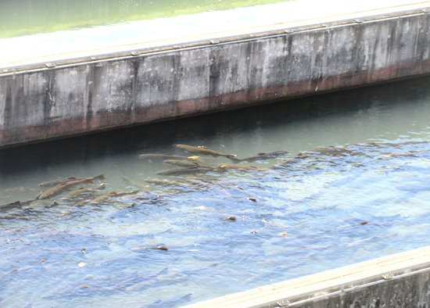
Critical Steps in Recovery of Spawning Habitat
- Secure instream tributary water flows to allow spawners to access spawning and rearing habitat in the few Upper Rogue tributaries unimpeded. With reclaimed spawning habitat in tributaries, the issue of lethal water temperatures during egg incubation below the dam is mitigated; this is likely the only way to address survival of early run Wild Spring Chinook. The project authorization document (House Document 566) suggests off channel spawning areas which have never been addressed, tributary spawning would complete this step.
- Big Butte Creek – Located 1.5 miles downstream from William Jess Dam/Lost Creek Reservoir. Wild/NP Spring Chinook love Big Butte Creek with nearly 9%; about 900 Wild/NP Spring Chinook spawning in Big Butte Creeks accessible lower 1 mile. The stream is water flow challenged during spawning migration with passage blockages; seek additional flows and secure improved passage at natural blockages. About 2/3 of the historical water flow are currently diverted. Extensive spawning and rearing habitat available, over 25 miles were likely to have been historic habitat prior to water withdrawals exceeding 125 cfs. . (See page 10)
- Elk Creek – located about 3 miles below William Jess Dam/Lost Creek Reservoir.
Water flow challenged, seek additional flows and passage to accessible spawning habitat. About 4 miles of habitat available in lower Elk Creek with additional water flow required. Heavily used by ESA Listed Coho Salmon and Steelhead. Spring Chinook would use this tributary in a greater amount with increased water flow. (25 to 50 CFS minimum needed). (See page 11)
- Little Butte Creek – located about 20 miles below William Jess Dam/Lost Creek Reservoir. There is extensive water diversion for flood irrigation within Little Butte watershed, 17 miles of spawning habitat accessible with increased water flows. Little Butte Creek violates states water quality standards. Little Butte Creek is now used by 22% of Rogue River ESA Listed Coho Salmon as well as steelhead and Chinook Salmon. . (See page 12)
- Bear Creek – Located near Medford about 23 miles downstream from William Jess Dam/Lost Creek Reservoir. There is extensive water diversion for irrigation. 20 miles of improved spawning habitat with increased water flows. Used by ESA Listed Coho Salmon, Steelhead and Chinook salmon. . (See page 13)
- Evans Creek - Used by ESA Listed Coho Salmon, Steelhead and Chinook salmon. (See page 14)

- The loss of spawning gravel migration from above the dam, gravel has been depleted by 42 years of blocked spawning gravel migration. The available spawning areas for surviving Wild/Natural producing Spring Chinook are diminished and over used throughout the Upper Rogue River. Tributary spawning will help address this overuse and diversity by expanding habitat outside of the mainstem. (the off channel spawning channels spoke of in HD 566) Spawning gravel augmentation in mainstem and tributaries is needed. Request that the USACE design and fund Upper Rogue River mainstem and tributary gravel augmentation, fish passage and gradient reduction where needed as a mitigation requirement.
House Document 566 used to authorize the Rogue Basin Project included an important supporting document from USFWS, the Report from Regional Director USFWS, stating on page 197: “Since Lost Creek Dam would prevent access of anadromous fish to upstream spawning areas, these fish would be concentrated in the remaining downstream areas, resulting in decreased spawning efficiency. Increased flows of good quality water downstream from the project at the onset of the spawning season would produce sufficient new spawning habitat to overcome the above-mentioned loss and in addition would increase spawning habitat for Spring Chinook salmon in downstream areas”. The expansion of Wild Spring Chinook spawning never occurred. This statement was a prime reason for project support, false as it was.)
- Loss of Biodiversity in Aquatic Ecosystems
The Rogue River needs an infusion of the types of food young juvenile salmon, steelhead and trout can grow strong and healthy on. Terrestrial insects need to be planted in Upper Rogue River and tributaries for heathy growth and rearing of juveniles. Some recent studies around the world are showing huge insect loses of up to 85% and many important terrestrial insects found in rivers a stream have declining populations, especially below dams.
Terrestrial insect life cycle - water born insects that supply the food chain of the Rogue River; the larvae emerge from the water turn into adult insects (caddis, stoneflies, mayflies, midges and more) they then migrate upstream to lay their eggs and the cycle begins again. On the Upper Rogue these low flying insects run into a 325 ft. tall dam blocking upstream migration those few that the make it over the dam are met with a 10 mile long lake and nowhere to productively lay their eggs so the cycle and the food source can prosper. Prior to the Dam the terrestrial insect population of the Upper Rogue was healthy, but as the years have passed fewer and fewer insects hatch and fish populations naturally decline, as seen in native trout, perpetuated by Loss of Biodiversity in the Aquatic Ecosystems of the Rogue River. Recovering spawning gravels will also help recover the small terrestrials juvenile salmon, trout and steelhead feed on.
Four Step Recovery Plan for Rogue River Spring Chinook / Native Trout / Coho / Steelhead
Water Quality – Spawning Habitat – Hatchery Supplementation – Food
- Secure tributary instream water flows and water quality needs.
- Recover spawning gravel losses by supplementation and expand tributary spawning.
- Food - Address the Loss of Biodiversity in Rogue River Basin Aquatic Ecosystems.
- Modernize the aging Cole Rivers Hatchery correcting shortfalls in required hatchery production.
Tributary Restoration
Big Butte Creek - 1 mile below William Jess Dam and Lost Creek Reservoir (about River mile 152).
Goal: Expand early run Spring Chinook spawning in Big Butte Creek to what must have been historically used by Spring Chinook, Native Trout, Steelhead and Coho Salmon. Likely 3000 spawning Spring Chinook once used Big Butte Creek, currently about 900 Early run wild Spring Chinook spawn within Big Butte Creek.
There are two primary water diverters in Big Butte Creek, City of Medford (25 cfs to 50 cfs) from Big Butte Springs in the headwaters and Eagle Point Irrigation District diverts 100 cfs about 11 miles up Big Butte Creek.
Estimated Costs for Big Butte Creek: $10.7 million, items below to be included but not limited to:
- Acquire permeant instream water rights all or part of the year. (Sept. Oct.)
- Fish passage / Barrier removal
- Address spawning gravel supplementation. (Off mainstem Spawning Channel) HD 566
- Improve Biodiversity in Butte Creek Aquatic Ecosystems (food) / riparian vegetation
- USACE engineering and funding of gradient reduction, fish passage and barrier issues requested.
- USACE review additional water storage options (Willow Lake?) request.
Cost total Big Butte Creek Project $10.7 million.
Estimated Increase
Spring Chinook 1,800
ESA Threatened Coho Salmon 350
Winter / Summer Steelhead 600
Total annual estimated increase 2,750
20 year ROI / $10.7 = $124.5 Million ROI
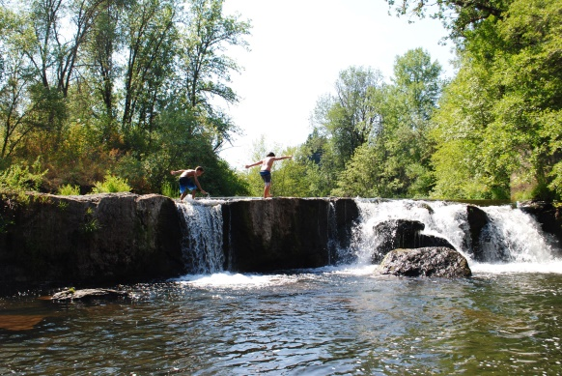

Lower Big Butte Creek at Crowfoot Falls / Fish Passage Barrier.
Elk Creek Fisheries Restoration
Elk Creek is located about 5 miles below William Jess Dam and Lost Creek Reservoir (about River mile 148).
Goal: Expand early run Spring Chinook spawning in Elk Creek to 500 spawning Spring Chinook, currently only a few Spring Chinook spawn within Elk Creek. Restore to pre Elk Creek Dam habitat and restore historic salmonid production of “1560 ESA listed Coho Salmon spawners, 1000 Summer Steelhead and 2000 Winter Steelhead” spawners with lots of Cutthroat trout.
With the addition of water flows of 50 cfs to 75 cfs and proper fish passage to Elk Creek this important tributary could produce 500 or more spawning Spring Chinook and aid ESA Threatened Coho Salmon, trout and Steelhead populations. Request a feasibility study from the USACE for a gravity or pump driven or tunnel water diversion over the low hill from Lost Creek Lake to be used during spawning migration (Sept. – Oct.) and to add gradient improvements for spawning gravel additions in the lower 4 to 5 miles of Elk Creek. Per Elk Creek Lake EIS
Elk Creek project outlined costs $10.7 million, items below to be included but not limited to:
- Water pipeline for Lost Creek Lake for additional 50 to 75 CFS during spawning migration.
- Gradient needs and spawning gravel supplementation.
- Biodiversity in Butte Creek Aquatic Ecosystems (food) / riparian vegetation
- USACE engineering of Pipeline and spawning gravel placement and gradient needs requested.
- Repair Fish Passage issues related to re-route of Elk Creek Highway and any water diversions.

Cost Total Elk Creek $10.7 million dollars
Estimated Increase
Spring Chinook 500
ESA Listed Coho 544
Steelhead (Summer & Winter) 2,269
Fall Chinook 300
Total annual estimated increase 3,613
Cost $10.7 = $163 Million 20 year ROI
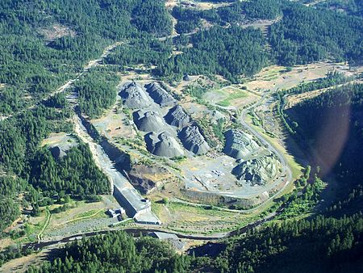

Abandoned Elk Creek Dam 3 mile upstream on Elk Creek.
“The Elk Creek Basin appears to have the capability of producing a large portion of wild migratory salmonids produced in the upper portion of the Rogue River Basin”.
Little Big Butte Creek Fisheries Restoration
Little Butte Creek is located 24 miles downstream from William Jess Dam and Lost Creek Reservoir (about River mile 129). Little Butte Creek near Eagle Point (10,000 population) is a 17-mile-long tributary of the Rogue River. Little Butte Creek because of gradient has the greatest opportunity for spawning expansion.
Little Butte Creek is water flow challenged because its flows are heavily diverted. Acquire permeant instream water rights all or part of the year. Could include canal from Rogue River as explained later.
- Funding help for water diverters to defray switch to pipe irrigation from flood irrigation.
- Purchase instream water rights from willing sellers.
- Gradient issues and spawning gravel supplementation.
- Biodiversity in Little Butte Creek Aquatic Ecosystems (food) / riparian vegetation.
- Address Water Quality issues.
- Fish passage / barrier removal.
- USACE review and recommend additional water storage or acquisition options, request.
Little Butte Creek project cost total $20 million dollars

Estimated Fisheries Increase
Spring Chinook 1,500
ESA Threatened Coho salmon 1,000
Winter / Summer Steelhead 1,600
Fall Chinook 1,000
Total annual estimated increase 5,100
20 year ROI / Cost $20 million = $186 million ROI
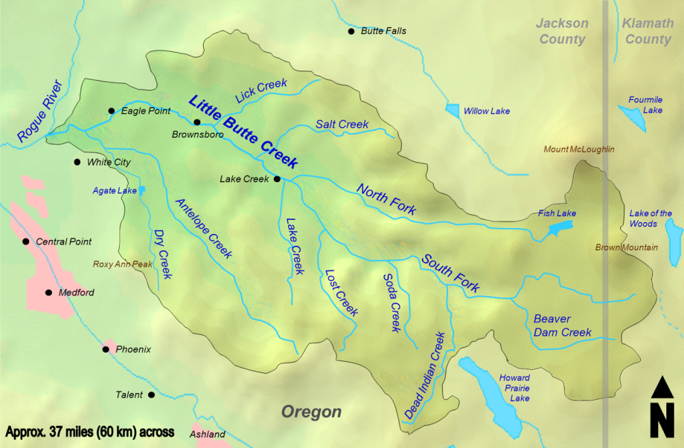
Bear Creek Fisheries Restoration
Bear Creek flows from Ashland to north of Central Point and is a 29 mile long tributary of the Rogue River at about river mile 123. Bear Creek is water flow challenged because its flows are heavily diverted. Bear Creek empties into the Rogue River west of Central Point Oregon. The 362-square-mile Bear Creek watershed includes approximately 290 miles of streams. Another 250 miles of irrigation canals transport water to farms across the watershed. Land use in the watershed is approximately 18 percent urban, 35 percent agriculture and 46 percent forest.
Estimated Costs for Bear Creek fisheries restoration: $20.6 million, ESA Listed Coho and Steelhead would benefit greatly. Items below to be included but not limited to:
- Acquire permeant instream water rights all or part of the year.
- Fund help for water diverters to defray switch to pipe irrigation from flood irrigation.
- Address fish passage and screening issues.
- Gradient issues and spawning gravel supplementation.
- Biodiversity in Bear Creek Aquatic Ecosystems (food) / riparian vegetation repair.
- Water Quality issues addressed.
- USACE review additional water storage and acquisition options, request. (canal from Rogue River?) 50 cfs to 75 cfs
Bear Creek project cost total $20.6 million dollars.
Estimated Fisheries Increase
ESA Threatened Coho salmon 1,000
Winter / Summer Steelhead 1,800
Fall Chinook 1,500
Total annual estimated increase 4,300
20 year ROI / cost $20.6 = $194.7 Million
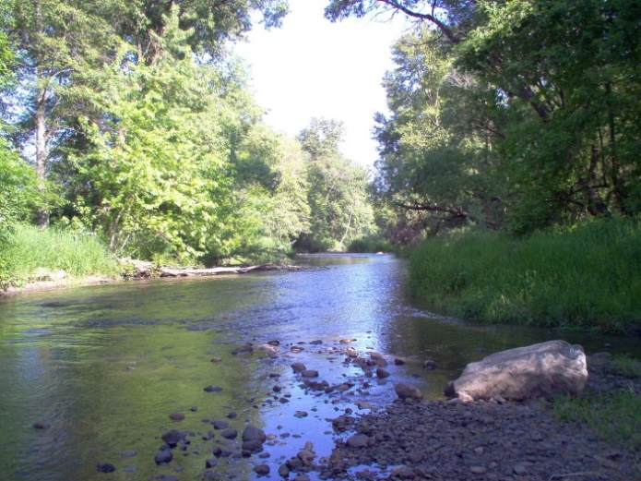

Evans Creek Fisheries Restoration
Evans Creek is located 35 miles downstream from William Jess Dam and Lost Creek Reservoir (about River mile 108) a 35-mile-long tributary of the Rogue River. Two abandoned dams on Evans Creek were demolished in 2015. Wimer and Fielder dams were formerly listed among the 10 worst dams in the state for migratory fish passage. Today there are still small abandon dams on Evans Creek in need of removal.
- Acquire permeant instream water rights all or part of the year.
- Fund help for water diverters to defray switch to pipe irrigation from flood irrigation.
- Fish passage and screening.
- Biodiversity in Bear Creek Aquatic Ecosystems (food)
- Riparian vegetation repair (blackberries).
- Address Water Quality issues.
Evans Creek project outlined cost total $7.1 million dollars.
Estimated Fisheries Increase
ESA Threatened Coho salmon 500
Winter / Summer Steelhead 600
Fall Chinook 750
Total annual estimated increase 1,850
20 year ROI / cost $7.1 = $83.7 Million
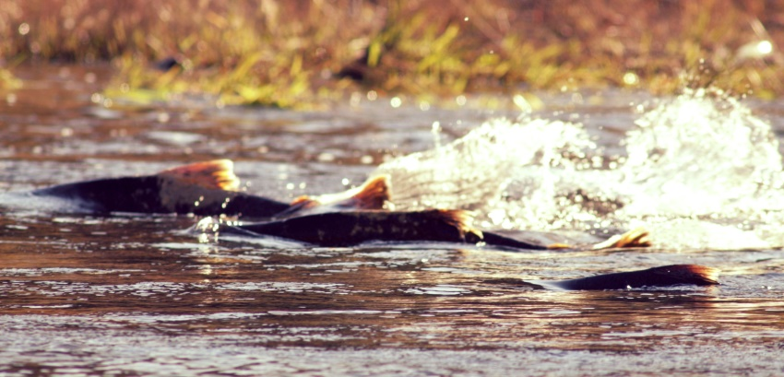

Mainstem Upper Rogue Fisheries Restoration – $18 million
“The salmon fishery of the Rogue River is especially important to the sport and commercial programs of Oregon. It is also significant on a national basis”.
The Upper Rogue River fisheries habitat has been changed by the 42 year old William Jess Dam and Lost Creek Reservoir in almost every way possible, water flows, available spawning habitat and Biodiversity in Aquatic Ecosystems (food) / riparian vegetation. The Upper Rogue mainstem has received little attention in fish restoration since the Dam was completed in 1977; mitigation for impacts of the Lost Creek Lake Project as required has been unaddressed on the Upper Rogue River mainstem where Wild/NP Spring Chinook are depleted by 60%.
The mainstem Upper Rogue has magnificent water flows year around thanks to the William Jess Dam and Lost Creek Reservoir. The Upper Rogue faces a shortage of gravels needed for spawning, after 42 years of blocked gravel migration, spawning gravels are much depleted throughout the 25 mile area of the Upper Rogue River.
Information given in the Authorization Document and House Document 566 state Spring Chinook spawning habitat would expand not decrease as it has. House Document 566 used to authorize the Rogue Basin Project included an important supporting document from USFWS, Report from Regional Director USFWS, stated on page 197: Since Lost Creek Dam would prevent access of anadromous fish to upstream spawning areas, these fish would be concentrated in the remaining downstream areas, resulting in decreased spawning efficiency. Increased flows of good quality water downstream from the project at the onset of the spawning season would produce sufficient new spawning habitat to overcome the above-mentioned loss and in addition would increase spawning habitat for Spring Chinook salmon in downstream areas.
Mainstem wintertime water temperatures are lethal to a great many of Wild/NP Spring Chinook fry as they hatch too early into a wintertime environment of little available food. We need to research and Introduce food sources to sustain early hatching Spring Chinook fry to prevent starvation.
A letter included in House Doc. 566 set conditions of project approval from the state of Oregon. Condition #9. “That flow release schedules for anadromous fish at each project be sufficiently flexible to meet special requirements for successful holding, spawning, egg incubation, rearing, and passage as future needs develop”.
The Rogue River needs an infusion of the types of food young juvenile salmon and steelhead can grow strong and healthy on. Terrestrial insects need to be planted in Upper Rogue river and tributaries for heathy growth and juvenile migration; depressed resident trout populations will also benefit. “During their fresh water residence, fry feed chiefly on terrestrial insects. Fry may form into schools during their freshwater residence”.
Prior to Lost Creek Lake Project construction Rogue River Spring Chinook runs average exceeded 34,000 Wild Spring Chinook annually. The project EIS requires a 13,020 adult hatchery return to the hatchery annually. When subtracted from about 34,000 average we should be receiving 20,980 wild Spring Chinook back annually we are getting around 9,000. About 11,317 below pre dam levels. The authorization documents promised expanded Wild Spring Chinook annual return; instead we face a $25.6 million dollar economic loss annually because of Lost Creek Project impacts on wild Spring Chinook populations. Wild / NP ESA Listed Coho, Summer and Winter Steelhead, Native Trout have all suffered losses as well; Elk Creek Dam is responsible for some of these impacts.
Estimated Costs for mainstem fisheries restoration: $18 million dollars, ESA Listed Coho and Winter/Summer Steelhead would benefit greatly as would resident rainbow and cutthroat trout. Items below to be included but not limited to:
- Spawning gravel supplementation.
- Biodiversity in Aquatic Ecosystems (food) / riparian vegetation
- Create Off Channel Spawning and Rearing Habitat as outlined in House Document 566
- Request USACE spawning gravel placement and off channel spawning develop a 20 year mainstem spawning and rearing plan.
With the addition of spawning gravels for expanded spawning and greater food sources for healthier juveniles there would be expected increases to Wild/NP salmon and steelhead in the mainstem:
(total annual increase 6,700)
Upper Rogue River Restoration $18 million dollars
Wild/NP Spring Chinook Salmon 2,500
Wild/NP ESA Listed Coho Salmon 500
Wild/NP Winter/Summer Steelhead 2,500
Wild/NP Fall Chinook 1,500
Total annual estimated increase 7,000
Rogue Mainstem 20 year ROI /cost $18 million = $317 Million
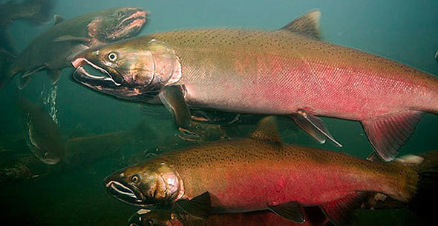
Projected Increase Forecast for Wild / Naturally Produced Fish
All fish and habitat funds within the Rogue River Fisheries Recovery Plan should have the ability to be moved to other in Rogue River basin anadromous fisheries needs.
Estimate Upper Rogue tributary salmon and steelhead increases of 24,563 and all would be Wild / NP stocks, with an annual economic value of $55.6 million.
Wild/NP Spring Chinook Salmon – 6,300 | Wild/NP Winter/Summer Steelhead – 9,369
Wild/NP ESA Listed Coho Salmon – 3,894 | Wild/NP Fall Chinook – 5,000
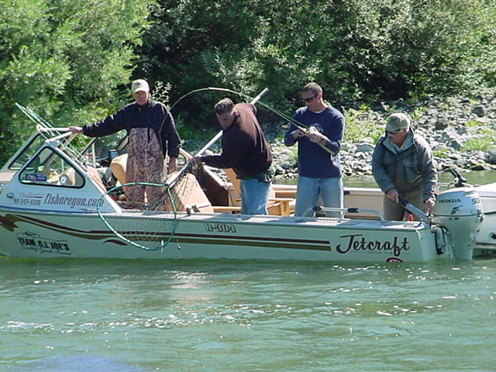

In-Stream Fisheries Restoration Portion Costs $87.1 million / 20 yr. ROI = $1.1 Billion
Return On Investment of 12.4 to 1
Big Butte Creek $ 10.7 million | Bear Creek $20.6 million
Elk Creek $ 10.7 million | Evans Creek $ 7.1 million
Little Butte Creek $ 20 million | Upper Rogue River Mainstem $18.0 million

Cole Rivers Hatchery Modernization $23 million Estimate
Call for US. Army Corps of Engineers to modernize Cole Rivers Hatchery to meet or exceed required hatchery mitigation production requirements of 13,020 hatchery produced Spring Chinook adults annually. Cole River Hatchery is 47 years old and has been failing its mission for 15 years or more, it is time for modernization.
Background: Cole Rivers Fish Hatchery was built by the Corps of Engineers to replace the fish and fishery that were lost due to dam construction and operation impacts. The primary purpose of Cole Rivers Hatchery is to produce Spring Chinook Salmon for mitigation for lost spawning habitat inundated by William Jess Dam which was completed in 1977, blocking 11 miles of the mainstem and portions of both the Middle Fork and South Fork of the Rogue River.
Included in House Document 566 required steps to be done in order to secure State of Oregon support for the project. #10 states: “That adequate propagation facilities be provided to compensate for the loss of anadromous fish sustained as a result of the construction of each dam”.
A Definition of adequate propagation for areas above Lost Creek Dam was included in the Final EIS for the Lost Creek Lake Project, 13,020 Adult Spring Chinook back to Cole Rivers Hatchery annually. Cole Rivers hatchery has never met the full requirement that “Losses sustained as a result of construction” (includes Wild Fish below the dam).
The Final Environmental Impact Statement May 8, 1972 for Lost Creek Dam (now William Jess Dam) clearly states Spring Chinook return above Lost Creek Dam required being 13,020 adults at the hatchery for authorization of the Lost Creek Dam Project.

This table shows the failure of the USACE to fulfill required hatchery supplementation over 38 years.
10 Year Avg. | Returning Hatchery Adults | Percentage of 13,020  Required Return | Smolt Release Return Percentage
1981 - 1990 | 19,643 | 151% 2.6% Return | 2.6%
1991 - 2000 | 24,518 | 189% 1.9% Return | 1.9%
2001 - 2010 | 7,898 | -40% .54% Return | 0.54%
2011 - 2018 | 5,172 | -62% .38% Return | 0.38%
2019 | 3,219 | -76% .20% Return | 0.20%
Cole Rivers Hatchery to produce 1.73 million healthy Spring Chinook Smolt to bring back 13,020 adults to the hatchery, only an average of 4876 returned over the last 15 years, a shortfall of 8,144 annually on average a $18.2 million economic loss average annually. In 2019 alone there was a $22.2 million loss.
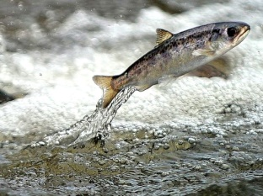

Hatcher Spring Chinook returns have been 100% adipose clipped the last 4 years

Sonar Fish Counters / Quantification $4.1 million
- USACE needs to fund quantitative monitoring of fish runs by using Sonar Fish Counters (DIDSON) or other technology to understand the numbers of Salmon and Steelhead returning as well as their altered life history in the Rogue River. The Rivers and Harbors Authorization included: “Provided, That the project is to be located, constructed, and operated to accomplish the benefits as set forth and described in the report and appendixes” This can only be realized only with quantitative fisheries monitoring which is not done now
- For 68 years there was a fish counting system for the Upper Rogue River at a private Dam – Gold Ray Dam which was removed in 2010 along with the counting station. There is great need for replacing this lost counting station with newer modern technology. USACE has no quantifying information for the last 9 years and going forward. Funding would be for multiple counting units, maintenance and operation for a 20 year period; $205,000.00 annually.

- Included in House Document 566 required steps to be done in order to secure State of Oregon support for the project. #8 states: “That provision be made for the cost of the full-time services of a qualified biologist to collect and correlate pertinent biological and hydrological data. Production success will depend on being able to accurately assess seasonal and annual variations in fish activity and optimum flow schedules”.

Funding of Full Time Fisheries Biologists
The State of Oregon required 13 steps be taken to secure the State of Oregon’s support for the Lost Creek Project – all 3 reservoirs. One of those requirements was a full time Project Biologist which was funded for some years and then went away in the late 1990’s.
8. “That provision be made for the cost of the full-time services of a qualified biologist to collect and correlate pertinent biological and hydrological data. Production success will depend on being able to accurately assess seasonal and annual variations in fish activity and optimum flow schedules”.

Hard to know what successes or failures are happening without a full time biologists. At least for the next 10 years USACE should fund 2 full time biologists to catch up and track Upper Rogue River restoration activities.

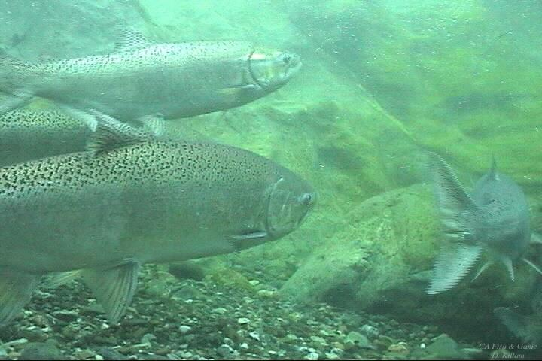

Restitution for Economic Damage to Wild and Hatchery Spring Chinook runs
$160 million
Rogue Basin Economies have long suffered with a nearly total closer on harvest of Wild Spring Chinook Salmon, higher license fees and reduced harvest opportunities. Fishermen once traveled from all over the United States to participate in the famous Rogue River fisheries. Spring Chinook were available from late March through July; this time frame was perfect for businesses coming out of a long winter and to kick off summer travel season. After over four decades of economic harm from a federal project that promised “No Harm to Fisheries” it is time for all to put effort and resources forward to restore and attempt to make whole the famous Rogue River fisheries and related economy.
Naturally Producing (NP) Spring Chinook annual returns have plummeted 60% from pre-dam numbers. The dam was completed in 1977 with primary purposes of Flood Control and Fisheries.
Final Environmental Impact Statement (page 3-10) - “any flood control plan detrimental to the fishery resource would be unacceptable.”
Information given in the Authorization Document and House Document 566 in 1962 states Spring Chinook spawning habitat would expand not decrease as it has. House Document 566 used to authorize the Rogue Basin Project included an important supporting document from USFWS, Report from Regional Director USFWS, stated on page 197: Since Lost Creek Dam would prevent access of anadromous fish to upstream spawning areas, these fish would be concentrated in the remaining downstream areas, resulting in decreased spawning efficiency. Increased flows of good quality water downstream from the project at the onset of the spawning season would produce sufficient new spawning habitat to overcome the above-mentioned loss and in addition would increase spawning habitat for Spring Chinook salmon in downstream areas.
- We are at a 60% below Wild/NP Spring Chinook pre-dam levels.
- There was a 47% decline in wild Spring Chinook in the mainstem just the first 14 years after Lost Creek Dam construction.
- We are at a 63% below required hatchery produced Spring Chinook project requirements over the last 15 years.
- 77% below required hatchery produced Spring Chinook project requirements over the last 4 years, the trend continues downward.
The Final Environmental Impact Statement May 8, 1972 for Lost Creek Dam (now William Jess Dam) clearly states Spring Chinook hatchery returns required to be 13,020 adults at the hatchery for authorization of the Lost Creek Dam Project.
Years | Wild/NP Avg. | Average Run Size | Hatchery Adult Component Avg. | Deficit Related To Dam  Combined Wild + Hatchery | Annual Average Economic Loss
1978 - 1987 |  | 40,631 |  | + 6,631 avg.
1988 - 1997 |  | 31,240 |  | -2,760 avg.
1998 - 2007 | 7,596 | 19,834 | 12,238 avg. | -14,166 avg. | $ 25,838,784
2008 - 2019 | 9,663 | 16,382 | 4,876 avg. | -19,461 avg. | $ 35,496,864
 |  |  | 2019 only 3,219 Adults returned | 21 yr. Economic Loss Total | $648.9 million
The combined Spring Chinook (hatchery and Wild/NP) shortfall over 21 years shows a $648.9 million dollar loss to the Rogue Basin economies and businesses.
Requested Economic Restitution per affected County totaling $160 million is 1/4 the Economic Impacts suffered over 21 yrs.
Curry County | $60 million | - Small Business restitution of $30 million
Jackson County | Not Participating | - Small Business restitution of $30 million
Josephine County | $30 million | - Small Business restitution of $10 million

Expenditure Rationalization
In September of 2019 a Petition for Endangered Species Listing for Spring Chinook Salmon on the entire Oregon Coast north of Cape Blanco near Port Orford was filed by the Native Fish Society, Center for Biological Diversity and Umpqua Watershed.
The Rogue River was not included but as the world’s largest producer of Spring Chinook Salmon it is foreseeable the Rogue could be drawn into the petition. The Coquille River and the Umpqua River on the north are included and boarder the Rogue River drainage in Coos and Douglas Counties. On the South the Klamath Basin boarders the Rogue Basin; there is filed ESA petition for Spring Chinook on the Klamath and Trinity Rivers.
- Rogue River Fisheries Recovery $87.1 Million (page 3)
“The mainstem and tributaries of the Rogue River collectively produce the largest population of wild anadromous salmonids in Oregon. The Rogue River supports recreational and commercial fisheries of immense importance to Oregon citizens and is nationally renowned for its diversity and productivity. Authorizing documents for Lost Creek Dam stipulate that fisheries enhancement is to be an important benefit of the dam”
Wild / naturally producing Spring Chinook Salmon are almost exclusively a mainstem spawner found only in the section of the Rogue River above Gold Ray Dam by habitat limitation. Big Butte Creek is the only tributary that supports a self-sustaining population of Spring Chinook Salmon. Spring Chinook spawners are blocked from increased use of Big Butte Creek and entering other tributaries because of water flow and quality mostly due to water withdrawal. Expanded use of Big Butte Creek and use of Elk Creek and Little Butte Creek would be possible for Wild / Naturally Produced Spring Chinook if water flows and water quality were sufficient from September 1st to October 15th.
“The Rogue River is the largest producer of spring chinook salmon Oncorhynchus tshawytscha among river basins south of the Columbia River. The stock contributes to commercial fisheries off the coast of northern California and Oregon (Jones 1988). Satterthwaite (1987) estimated that ocean landings of the 1971-76 brood years averaged about 60,000 wild fish annually. The stock also supports important recreational fisheries in the Rogue River. Cramer et al. (1985) estimated that freshwater harvest averaged about 7,000 adults annually during 1964-81. 'This estimate did not include jacks smaller than 60 cm (24 inches)”

Today the Rogue River’s contribution is ocean fisheries is likely extremely reduced and in river harvest of Spring Chinook is regulated to primarily a hatchery stocks only. Prior to the dam the bag limit was 3 wild Spring Chinook per day throughout the river.
- Mainstem Upper Rogue River Restoration (page 15-16 of this document)
  - Restore Spawning Gravel in the mainstem. Spawning gravel migration was near totally stopped above Big Butte Creek and very depleted below that point to Elk Creek confluence.
  - Seek off channel spawning opportunities as referred to in House Document 566 and the Final EIS. “Any acceptable solution would have to provide a reasonably high degree of flood control, satisfy known irrigation needs, involve a minimum of fishery problems, and provide for overall fishery resource enhancement. “so located as to provide a maximum of flood control and water conservation without serious detriment to spawning and rearing areas for the fishery resource”.
“Restitution facilities would consist of fish-production facilities such as a fish hatchery or possibly spawning channels and related works, as might be found necessary upon completion of detailed studies in cooperation with Federal and state fish and wildlife agencies following project authorization.
j. Fishery facilities. – “The projects proposed herein include provisions for construction and operation of facilities for enhancement of fish and wildlife resources of the basin, and for mitigation of and restitution for losses occasioned by project construction”.

7. “That flow release schedules for anadromous fish at each project be sufficiently flexible to meet special requirements for successful holding, spawning, egg incubation, rearing, and passage as future needs develop”. Authors note: To have successful spawning, egg incubation and rearing, spawning gravel and proper water temperatures are essential – no spawning gravel no fish. There is likely a 60% decline in Wild stocks today with an even more sever loss of the vital early run Spring Chinook. A 47% decline was documented in the first 4 years after dam construction.
  - Spring Chinook Interbreeding with Fall Chinook
Fall Chinook are migrating further up river to spawn and Spring Chinook are spawning later (Less Early Run Spring Chinook) creating an overlap in spawning. The dam has changed the life history of the Wild Spring Chinook into a later spawner. Flows are much cooler out of the dam and about double the flow in summer months which brings Fall Chinook further up river to spawn. In the 10 year period before the dam an average of 2422 Fall chinook passed the Gold Ray Dam counting station, the 10 years after Lost Creek Dam operations, 5614 Fall Chinook passed the Gold Ray counting station in average year.
This is a 131% increase in Fall Chinook spawning in the Upper Rogue River 14 years after the dam was completed together with a 60% decline in Wild Spring Chinook the time to begin to save Wild Spring Chinook was over 25 years ago. Removal of 3 mainstem dams since 2010 has likely accelerated the march of Fall Chinook into the Upper Rogue River and into Spring Chinook habitat as well.
To combat the infusion of Fall Chinook into historical Spring Chinook spawning areas lost spawning gravels need to be mitigated and off channel spawning in tributaries needs to be attained as promised in the Project Authorization, House Document 566.
“In recent years, fishery managers have expressed concern about the wild component of the run. Production (ocean catch plus freshwater escapement) of broods produced after the first 4 years of full operation of Lost Creek Dam at river kilometer (RK) 253 averaged 53% of the production from pre-impoundment broods (Satterthwaite 1987).
(Author Comment: 47% decline in Spring Chinook production in the first 4 years after the dam was built.
“The cost of mitigation of damages caused by the projects to fish and wildlife are considered as joint costs and are allocated to all project purposes. Under the Fish and Wildlife Coordination Act, such costs on Bureau of Reclamation projects have been allocated to fish and wildlife and considered non-reimbursable.”

Spring Chinook Spawning Distribution
1. Adults that migrated earliest spawned farthest upstream.
2. Spawning of fall chinook salmon and spring chinook salmon overlapped in the area between
Trail Creek and the pool behind Gold Ray Dam. Few fall chinook salmon, but many spring
chinook salmon, spawned upstream of Trail Creek.
3. We did not detect any change in the spawning distribution of fall chinook salmon, possibly
because we sampled few adults that originated from pre-impoundment broods.
4. Spring chinook salmon broods produced after full operation began at Lost Creek Dam
spawned farther downstream compared with pre-impoundment broods.
5. A decrease in the relative abundance of early migrating adults, compared with late migrating
adults, was responsible for the downstream shift in the spawning distribution of spring
chinook salmon.
6. Increased water temperature during the period eggs and alevins incubated in the gravel, or
increased harvest rate within the sport fishery upstream of Gold Ray Dam, may have
decreased the relative abundance of early migrants among wild spring chinook salmon that
returned to the Rogue River.

In the Authorization Document for the Lost Creek Lake Project the State of Oregon set conditions that must be met for approval and those conditions were placed into the Authorization Document.

7. “That flow release schedules for anadromous fish at each project be sufficiently flexible to
meet special requirements for successful holding, spawning, egg incubation, rearing, and
passage as future needs develop.” State of Oregon Fish Commission
  - Loss of Insect Biodiversity in Rogue River Ecosystems
Dams modify water quality and flow patterns downstream
The Rogue River needs an infusion of the types of food young juvenile salmon, steelhead and trout can grow strong and healthy on. Terrestrial insects need to be planted in Upper Rogue River and tributaries for heathy growth and rearing of juveniles. Some recent studies around the world are showing huge insect loses of up to 85% and many important terrestrial insects found in rivers a stream have declining populations especially below dams.
Terrestrial insect life cycle - water born insects that supply the food chain of the Rogue River; the larvae emerge from the water turn into adult insects (caddis, stoneflies, mayflies, midges and more) they then migrate upstream to lay their eggs and the cycle begins again. On the Upper Rogue these low flying insects run into a 325 ft. tall dam blocking upstream migration those few that the make it over the dam are met with a 10 mile long lake and nowhere to productively lay their eggs so the cycle and the food source can prosper. Prior to the William Jess Dam and Lost Creek Reservoir the terrestrial insect population of the Upper Rogue was healthy, but as the years have passed fewer and fewer insects hatch and fish populations naturally decline as seen in native trout perpetuated by Loss of Biodiversity in the Aquatic Ecosystems of the Rogue River. Recovering spawning gravels will also help recover the small terrestrials juvenile salmon, trout and steelhead feed on as this is the preferred habitat for these insects not cobble.

Upper Rogue River Restoration Project $18 million.
Estimated Salmonid Increase (Not including Native Trout)
Spring Chinook 2,500
ESA Threatened Coho Salmon 500
Winter / Summer Steelhead 2,500
Fall Chinook 1,500
Total annual estimated increase 7,000
Cost $18 million = $317 Million 20 year ROI

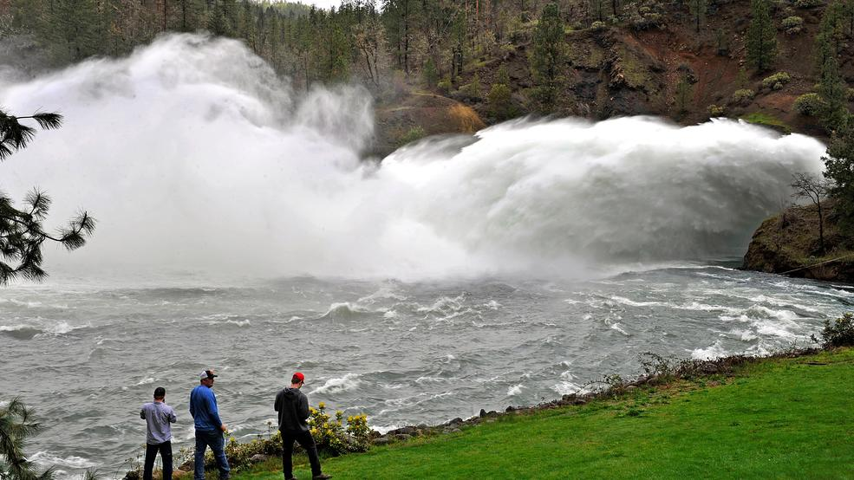
Lost Creek / William Jess Dam dumping stored water.
b) Big Butte Creek Expenditure Rationalization (page 10)
Large tributary 1.5 miles below Lost Creek Dam that is critical to Early Run Spring Chinook survival. There is a partial barrier one mile up Big Butte Creek (see Crowfoot Fall’s picture). Big Butte Creek has the wintertime water temperatures needed for early run Spring Chinook egg incubation no longer available in the mainstem Rogue due to water quality issues caused by the dam. Big Butte Creek supplies water temperatures ranging from the mid 30’s to 39 degrees during incubation of eggs. The mainstem before the dam had nearly identical wintertime water temperatures, now water temps below the dam are closer to 42 to 43 degrees in winter – 4 to 5 degrees higher than historically. Why is this important; Spring Chinook eggs hatch timing is related to water temperatures during incubation – the warmer the water the earlier the hatch. Early hatchlings face wintertime environment with a food shortage and perish. As the early run Spring Chinook decline later spawning Spring Chinook take center stage. This perpetuates a Life History change. Rogue Basin Dam Fisheries Evaluation / May 1991 page 3 show a decline of 47% in productivity in the first 14 years after the dam was constructed.
Improving early Spring Chinook spawning in Big Butte Creek will entail water flow and habitat improvements. Big Butte Creek spawning gravel is poor and water flow challenged; because its flows are heavily diverted (about 2/3 to 3/4 of flow). Big Butte Creek is loved by Spring Chinook as nearly 9% of Wild Spring Chinook (about 900) spawn in just 1 mile of Lower Big Butte Creek. In places the gradient is steep.
ODFW Gravel migration studies show surprisingly good results. Big Butte Creek has > 25 miles of potential spawning habitat. There are currently stream flows of about 50 to 70 cfs during peak spawning time of Sept. thru early October with likely 125 CFS to 150 CFS being diverted.
Big Butte Creek Restoration Project $10.7 million.
Estimated Salmonid Increase (Not including Native Trout)
Spring Chinook 1,800
ESA Threatened Coho Salmon 350
Winter / Summer Steelhead 600
Total annual estimated increase 2,750
Cost $10.7 = $125 Million 20 year ROI

With a unimpeded stream flow of over 200 cfs during September and October successful spawning by all salmonids would be greatly improved. Crowfoot Falls needs to be made fish passage friendly and some steep gradient in Big Butte Creek leveled out; spawning gravel needs to be introduced.
c) Elk Creek Expenditure Rationalization (page 11)
“Coho salmon, steelhead, chinook salmon, and cutthroat trout spawn in the Elk Creek Basin. Coho salmon in southern Oregon and northern California have been listed as threatened by the National Marine Fisheries Service (NMFS) under the Endangered Species Act.”
“Elk Creek Dam, an incomplete flood-control structure that blocked fish migration for more than 20 years, was partly demolished in 2008 to restore fish passage. When the Elk Creek Dam was about one-third finished, lawsuits to protect endangered salmon and other migratory fish led to a court injunction that stopped construction in 1987. After 1992, fish trying to swim past the dam were trapped and hauled around it in trucks. Litigation and political battles lasting more than 20 years led to the compromise of demolishing about 15 percent of the dam and leaving the rest intact so that it might be restored in the future”.
Elk Creek is located about 5 miles below William Jess Dam and Lost Creek Reservoir (about River mile 148). No fish passage was provided between 1983 and 1992 when a trap and haul program was put in place after; “Oregon Department of Fish and Wildlife (ODFW) staff observed hundreds of adult salmonids immediately downstream of the dam. These observations increased concern that adult salmonids were unable to pass Elk Creek Dam. “
“The Elk Creek project was initiated in 1971, the third dam authorized by Congress to be built in the Rogue River Basin. After years of litigation the project was stopped in 1988, leaving an incomplete dam 83 feet tall, one-third its designed height. Once construction was stopped, plans were developed to restore Elk Creek to a free-flowing creek. The dam was notched on Aug. 17, 2008, and the Corps diverted Elk Creek into the new channel on Sept. 15, 2008”.
Goal: Expand early run Spring Chinook spawning in Elk Creek to 500 spawning Spring Chinook, currently only a few Spring Chinook spawn within Elk Creek and restore damaged Elk Creek spawning habitat from partial construction of undeveloped Elk Creek Dam. Bring Coho and Steelhead back to pre-Elk Creek Dam spawning populations.
Pre Elk Creek Dam Run sizes |  | Post Elk Creek Dam Run sizes
ESA Listed Coho Salmon | 1,560 | ESA Listed Coho Salmon | 1,016
Summer / Winter Steelhead Combined | 3,000 | Summer / Winter Steelhead Combined | 731
Wild Spring Chinook | >100 | Wild Spring Chinook | 30
Restoration of pre-Elk Creek Dam Wild Coho returns of 1560 avg. /Wild Summer Steelhead return of 1000 avg. and Wild Winter Steelhead returns of 2000 Steelhead avg. (USACE 1980), with lots of Cutthroat trout. With the addition of water flows and proper fish passage to Elk Creek this major tributary could produce 500 or more spawning Wild Spring Chinook and aid impacted ESA Threatened Coho Salmon, Native Trout and Steelhead. (No counts of Resident Trout were attempted because they were deemed non-migratory and the studies funded by USACE were for migratory salmonids).
Elk Creek Dam Timelines: Note there was a tunnel through Elk Creek dam that evacuated water flow of Elk Creek it was never suitable for fish passage that is way the Trap and Haul program was operated 1992 to 2004. “Spawning surveys and trap catches of juveniles suggested that few adult coho salmon or steelhead passed the dam during the 1991-92 run year even though Oregon Department of Fish and Wildlife (ODFW) staff observed hundreds of adult salmonids immediately downstream of the dam. These observations increased concern that adult salmonids were unable to pass thru the baffled diversion tunnel”.
“In response to that concern, under a cooperative agreement, USACE funded ODFW to operate the temporary fish collection facility and transport fish above the dam, beginning in autumn of 1992. Adult salmonids were trapped below the dam and were trucked and released upstream of the dam during the 1992-93 and 1993-94 run years. Trap catches totaled 38 coho salmon and 119 steelhead in 1992-93 and 86 coho salmon and 120 steelhead in 1993-94. Returns in both run years were very low compared with ODFW estimates of historic returns that averaged 1,560 coho salmon, 1,000 summer steelhead, and 2,000 winter steelhead (USACE 1980).

“High stream flows during the period from early December through mid-March limited opportunities to safely hand remove debris from culverts on West Branch, Alco and Middle Creeks that cross Elk Creek Road”. Culverts may block upstream migration for adults or passage for juveniles during low flow periods. Document indicates fish passage issues at culverts located in major spawning tributaries of Elk Creek. “Executive Order 11988, Floodplain Management, outlines the responsibilities of federal agencies in the role of floodplain management. (4) Restore and preserve the natural and beneficial values of the base floodplain”.
Construction Starts | 1983 | Author was present when first dirt was turned
Court Order Ends construction at 83 foot | 1988 | No or poor fish passage for 6 years 1985 to 1991
Trap and Haul Migratory Fish Begins | 1992 | 4 yrs. after construction ended
Trap and Haul Ends | 2004 | Ends Culvert Cleaning at 3 tributaries / fish passage
Elk Creek Dam notched | 2008 | No or poor fish passage for 4 years 2004 to 2008
New Elk Creek Road Built with Culverts and poor fish passage over tributaries | 1986 | Not yet addressed or repaired
 |  | 20 years of limited fish passage at the dam site
From NMFS Recovery Plan for Coho Salmon
32.7 Recovery Strategy “The most immediate need for habitat restoration and threat reduction in the Upper Rogue River is in those areas currently occupied by coho salmon in the headwaters of Evans, Trail, Elk, Big Butte, and Little Butte Creeks. Unoccupied areas must also be restored to provide enough habitat for coho salmon to achieve recovery. The degraded conditions of the Upper Rogue River habitat, combined with the depressed coho salmon population size and distribution, increases the risk of extinction of this inland coho salmon population, which is critical to recovery of the Interior Rogue River diversity stratum. The greatest factor limiting recovery of coho salmon in the Upper Rogue River is the lack of suitable rearing habitat for juveniles. The processes that create and maintain such habitat must be restored by restoring flow, increasing habitat complexity within the channel, restoring off channel rearing areas, and reducing threats to instream habit”.
Remedies
Create off Channel spawning in Elk Creek to help address mainstem Rogue River spawning habitat decline and restore Elk Creek spawning habitat.
- Request a feasibility study and funding from the USACE for a gravity, pump driven pipe line over the hill from Lost Creek Lake or a tunnel to be used during spawning migration with a goal of 50 cfs to 75 cfs in additional flow to Elk Creek Sept., Oct., Nov. time frame and to add gradient improvements for spawning gravel additions in the lower 4 to 5 miles of Elk Creek and tributaries. “You suggest a small after bay for reregulating purposes or, as an alternative, a tunnel from Lost Creek Reservoir to Elk Creek Reservoir, with a peaking plant at the downstream end of the tunnel and a base-load plant at Elk Creek Dam”
- Correct Fish Passage issues resulting from the re-routed 9.2 miles of Elk Creek Road on the Westside of Elk Creek over West Branch Elk Creek, Alco Creek and Middle Creek. Replace culverts with bridges to solve fish passage issues.

Elk Creek Restoration Project $10.7 million.
Estimated Salmonid Increase (Not including Native Trout)
Spring Chinook 500
ESA Threatened Coho Salmon 544
Winter / Summer Steelhead 2,269
Fall Chinook 300
Total annual estimated increase 3,613
Cost $10.7 = $163 Million 20 year ROI
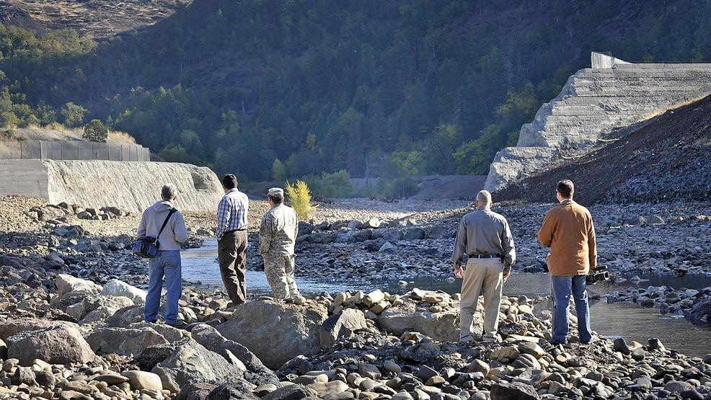
Elk Creek Dam notched 2008 – 25 years of no or poor fish passage.

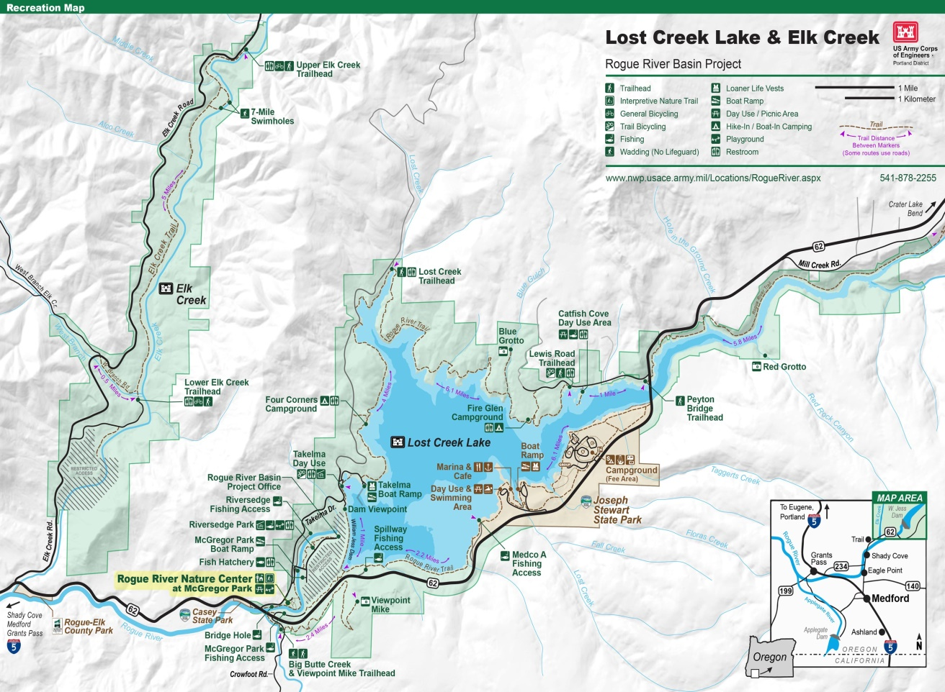
Upper Rogue Map showing Rogue River – Lost Creek, Elk Creek and Big Butte Creek

  - Little Butte Creek Expenditure Rationalization (12)
Little Butte Creek basin is recognized as the best option for fisheries enhancement within the Upper Rogue River. Many species use this stream for spawning; 22% of Rogue River ESA Listed Coho Salmon spawn in Little Butte Creek. Portions of Little Butte run dry in summer months and Lower Little Butte Creek is very water quality challenged; big habitat and juvenile survival gains can be made in a restored Little Butte Creek basin.
“Despite being moderately polluted, the creek is one of the best salmon-producing tributaries of the Rogue River. Coho and Chinook salmon migrate upstream each year; however, several dams hinder their progress. “Fall chinook salmon, coho salmon, and winter and summer steelhead use the Little Butte system for spawning and rearing. Resident cutthroat, brook and rainbow trout are also present in good numbers. Little Butte Creek contributes significantly to the fishery resource of the Rogue River”.

“Overall, high temperature is the most common problem in the Little Butte Creek watershed. This is most likely caused by water diversion and depleted riparian zones. Approximately 53 percent of riparian zones in the watershed are damaged due to agriculture or deforestation, while 43 percent are classified as healthy. Another threat to healthy riparian zones are invasive blackberries, which crowd out native vegetation and provide little shade. The resulting higher water temperatures can be very harmful to anadromous fish. High concentration of bacteria is also an issue”.
Remedies
- Funding help for water diverters to defray switch to pipe irrigation from flood irrigation.
- Purchase instream water rights from willing sellers
- Address Fish Passage issues.
- Gradient issues and spawning gravel supplementation.
- Biodiversity in Little Butte Creek Aquatic Ecosystems (food).
- Riparian vegetation repair. (blackberries)
- Address Water Quality issues.
- USACE review and recommend additional water acquisition options, possibly using water canal from the Rogue River 50 to 75 CFS.
Little Butte Creek Restoration Project $20 million.
Estimated Salmonid Increase (Not including Native Trout)
Spring Chinook 1,500
ESA Threatened Coho Salmon 1,000
Winter / Summer Steelhead 1,600
Fall Chinook 1,000
Total annual estimated increase 5,100
20 year ROI / cost $20 = $231 Million ROI
“As a part of Lost Creek and Elk Creek projects there is a potential "exchange-of-flow" arrangement. It would be an element of the U.S. Bureau of Reclamation Medford Division Project which would use water stored in Lost Creek and Elk Creek for irrigation, fish life enhancement, and recreation purposes. USBR study of Medford Division is not yet complete, so final details are not known. The exchanges contemplated, however, would involve: (a) substitution of stored water, from Lost Creek and Elk Creek by canal, for natural flow diverted from Bear and Little Butte Creeks as an irrigation supply; and (b) consequent maintenance, in those streams, of equal amounts of natural flow now diverted for irrigation. Water quality enhancement will include all aspects of returning flows in, and conditions along, those streams to a more-nearly-original condition. Stored water for use in such exchanges would be released from Lost Creek, Elk Creek, or both, as needed and in relative amounts based on conditions (amount of water available, etc.) in each storage project at the time”.
A delivery system of stored water (canal) from Lost Creek Dam to aid Fisheries Restoration in both Little Butte Creek and Bear Creek was foreseen in the Final EIS for Lost Creek Lake Project, this identified fisheries restoration option needs to be revisited for Upper Rogue River Restoration.
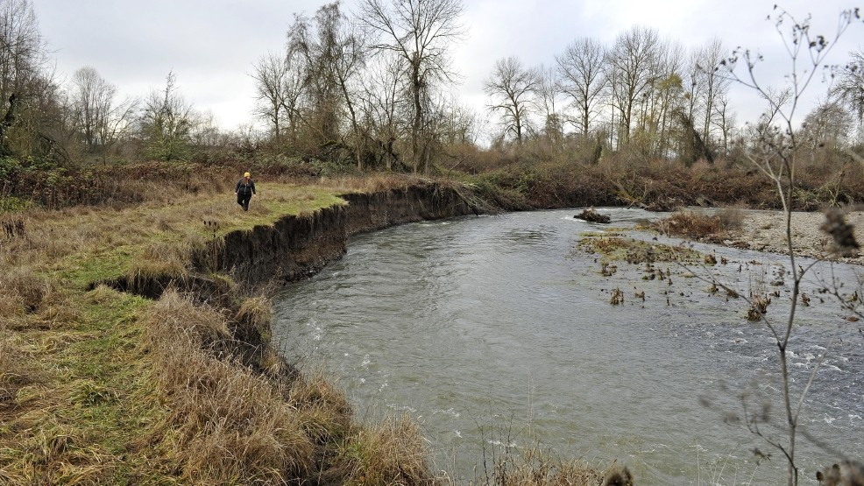
Little Butte Creek Restoration
Alexis Brickner, restoration program manager for the Rogue River Watershed Council, walks along Little Butte Creek in Eagle Point Friday. This section of the creek is part of an effort to redirect it toward its pre-flood meander toward the Rogue River through city of Eagle Point property west of Highway 62. [Mail Tribune / Jamie Lusch]
  - Bear Creek Expenditure Rationalization (page 13)
Remedies
- Funding help for water diverters to defray switch to pipe irrigation from flood irrigation.
- Purchase instream water rights from willing sellers
- Address Fish Passage issues.
- Gradient issues and spawning gravel supplementation.
- Biodiversity in Bear Creek Aquatic Ecosystems (food)
- Riparian vegetation repair (blackberries)
- Address Water Quality issues.
- USACE review and recommend additional water acquisition options, possibly using water from the Rogue River 25 to 50 CFS.

Bear Creek Restoration Project $20 million.
Estimated Salmonid Increase (Not including Native Trout)
ESA Threatened Coho Salmon 1,000
Winter / Summer Steelhead 1,800
Fall Chinook 1,500
Total annual estimated increase 4,300
Cost $20 = $194 Million 20 year ROI
“As a part of Lost Creek and Elk Creek projects there is a potential "exchange-of-flow" arrangement. It would be an element of the U.S. Bureau of Reclamation Medford Division Project which would use water stored in Lost Creek and Elk Creek for irrigation, fish life enhancement, and recreation purposes. USBR study of Medford Division is not yet complete, so final details are not known. The exchanges contemplated, however, would involve: (a) substitution of stored water, from Lost Creek and Elk Creek by canal, for natural flow diverted from Bear and Little Butte Creeks as an irrigation supply; and (b) consequent maintenance, in those streams, of equal amounts of natural flow now diverted for irrigation. Water quality enhancement will include all aspects of returning flows in, and conditions along, those streams to a more-nearly-original condition. Stored water for use in such exchanges would be released from Lost Creek, Elk Creek, or both, as needed and in relative amounts based on conditions (amount of water available, etc.) in each storage project at the time”.
A delivery system of stored water (canal) from Lost Creek Dam to aid Fisheries Restoration in both Little Butte Creek and Bear Creek was foreseen in the Final EIS for Lost Creek Lake Project, this identified fisheries restoration option needs to be revisited for Upper Rogue River Restoration.
  - Evans Creek Restoration (page 14)
Home to ESA Listed Coho Salmon, Summer and Winter Steelhead, Chinook Salmon and Native Trout
Instream Factors Limiting Fish Production
- Limited Salmonid Habitat due to lack of large woody debris in the stream (rearing)
- High water temperatures (rearing)
- Spawning gravel reduced due to sedimentation (spawning)
- Pools aggregated due to granitic sands (rearing, migration)
- Lack of winter Coho refugia/side channels
- Lower Insect production and quality
- Low summer flow (rearing, migration)
Remedies
- Funding help for water diverters to defray switch to pipe irrigation from flood irrigation.
- Purchase instream water rights from willing sellers.
- Address Fish Passage issues (barriers).
- Address spawning areas and gravel needs.
- Biodiversity in Evans Creek Aquatic Ecosystems (food)
- Riparian vegetation repair.
- Address Water Quality issues.
The removal of the two largest abandoned diversion dams Fielder Creek Dam and Wimer Dam; formerly listed among the 10 worst dams in the state for migratory fish passage, were demolished in 2015 and opened or improved passage to 70 miles of fish habitat. Further work is needed for Fisheries Restoration in Evans Creek.
Evans Creek Restoration Project $7.1 million.
Estimated Salmonid Increase (Not including Native Trout)
ESA Threatened Coho Salmon 500
Winter / Summer Steelhead 600
Fall Chinook 700
Total annual estimated increase 1850
20 year ROI / cost $7.1 = $83.7 Million ROI
Evans Creek has 9 abandoned irrigation dams remaining further work is needed for Fisheries Restoration in Evans Creek.
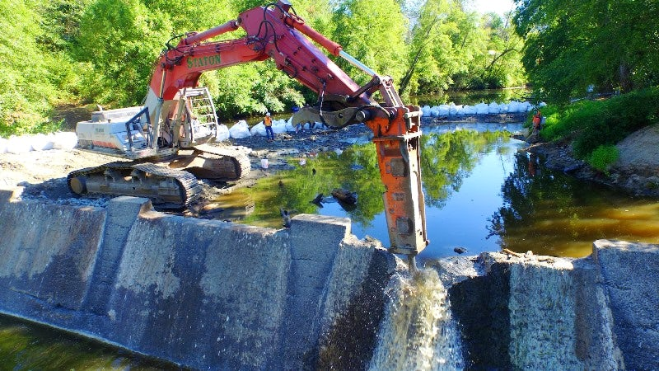

Supporting Documents
Hatchery Spring Chinook Returns – required return at Hatchery per Final EIS of 13,020 Adults.
Year | Hatchery Pond Ct. |  | Less Wild & Jacks |  | Hatchery Adults | Deficit of 13,020 Return  % of Release Return
2019*  As of 10/1 | 3,801  99.9% in |  | 217 Wild = 6%  365 Jacks = 9% |  | 3,219 Adults  Shortfall -9,801 | 76% Deficit  0.20% Release / Return
2018 | 5,027 |  | 233 Wild = 4.5%  720 Jacks = 14.5% |  | 4,074  Shortfall -8,947 | 69% Deficit  0.24% Release / Return
2017 | 4,280 |  | 338 Wild = 7.9%  973 Jacks = 21% |  | 2,969  Shortfall -10,051 | 77% Deficit  0.18% Release / Return
2016 | 2,698 |  | 182 Wild = 7%  574 Jacks = 25% |  | 1,942  Shortfall -11,078 | 85% Deficit  0.12% Release / Return
2015 | 8,278 |  | 406 Wild = 4.9%  310 Jacks = 4% |  | 7,562  Shortfall -5,458 | 54% Deficit  0.46% Release Return
2014 | 8,563 |  | Estimate 7.75% Wild = 663  Estimate Jacks = 20% = 1,712 |  | 6,188  Shortfall -6,832 | 53% Deficit  0.47% Release Return
2013 | 9,759 |  | Estimate 7.75% Wild = 759  Estimate Jacks = 20% = 1,952 |  | 7,044  Shortfall -5,976 | 46% Deficit  0.51% Release Return
2012 | 10,995 |  | Estimate 7.75% Wild = 825  Estimate Jacks = 20% = 2,198 |  | 7,972  Shortfall -5,048 | 39% Deficit  0.57% Release Return
2011 | 6,748 |  | Estimate 7.75% Wild = 523  Estimate Jacks = 20% = 1,350 |  | 4,051  Shortfall -8,969 | 69% Deficit  0.30% Release Return
2010 | 8,243 |  | Estimate 7.75% Wild = 639  Estimate Jacks = 20% = 1,648 |  | 5,956  Shortfall -7,064 | 54% Deficit  0.43% Release Return
2009 | 5,526 |  | Estimate 7.75% Wild = 429  Estimate Jacks = 20% = 1,106 |  | 3,991  Shortfall -9,029 | 69% Deficit  0.28% Release Return
2008 | 5,703 |  | Estimate 7.75% Wild = 442  Estimate Jacks = 20% = 1,140 |  | 4,121  Shortfall -8,899 | 68% Deficit  0.29% Release Return
2007 | 5,271 |  | Estimate 7.75% Wild = 411  Estimate Jacks = 20% = 1,140 |  | 3,763  Shortfall -9,257 | 72% Deficit  0.27% Release Return
2006 | 5,243 |  | Estimate 7.75% Wild = 404  Estimate Jacks = 20% = 1,048 |  | 3,784  Shortfall -9,236 | 72% Deficit  0.27% Release Return
2005 | 8,875 |  | Estimate 7.75% Wild = 688  Estimate Jacks = 20% = 1,776 |  | 6,410  Shortfall -6,610 | 51% Deficit  0.46% Release Return
Avg. | 6,252 |  | 14 yr. Wild Average = 541  14 yr. Jack Average = 1,575 |  | Avg. Return 4,868  Shortfall – 8,152 | 62.5% Deficit  0.28% Release Return
Smolt to adult return based on 1,703,000 smolt release annually |  | Required Adult Annual Hatchery Return 13,020 Adults |  | Actual 15 yr. Hatchery Adult avg. = 4,876 | Used 2009 Economic Study of Rogue River Salmon from ECONorthwest  Dollar amounts are in 2007 Dollars $1,824.00 or $2,263.00 in 2019 |  | Annual Average  (15 year) economic loss @ $2,263.00 per fish =$18.4 million per year  15 yr. Deficit = $277 million

Cole Rivers Hatchery Adult Collection Reports from ODFW
Required return 13,020 annually: The Final Environmental Impact Statement May 8, 1972 for Lost Creek Dam (now William Jess Dam) clearly states Spring Chinook hatchery returns required to be 13,020 adults at the hatchery for authorization of the Lost Creek Dam Project.
2016 First Year 100% marked Return for Spring Chinook. Highlighted numbers do not count toward Hatchery Adult production requirements.
2016 Season Cole Rivers Hatchery Adult Collection & Inventory
 | Male | Female | Jack | Sub-jack | Total
Unmarked (Wild) | 88 | 55 | 12 | 27 | 182 – wild don’t count
Marked* | 873 | 1069 | 197 | 377 | 2,516 – Adults only 1,962
Recaptures | 32 | 7 | 152 | 1 | 192 – recycled don’t count
total | 961 | 1124 | 209 | 404 | 2,698 – actual 1,962
*Marked fish are hatchery fish with clipped adipose fin.
2017 Season Cole Rivers Hatchery Adult Collection & Inventory
 | Male | Female | Jack | Sub-jack | Total
Unmarked (Wild) | 169 | 122 | 31 | 16 | 338 – wild don’t count
Marked* | 1414 | 1620 | 498 | 410 | 2,516 – Adults only 2,969
Recaptures | 169 | 0 | 186 | 54 | 192 – recycled don’t count
total | 1583 | 1742 | 529 | 426 | 4,280 – actual 2,969
*Marked fish are hatchery fish with clipped adipose fin.
https://www.dfw.state.or.us/fish/fish_counts/rogue_river/cole_rivers/2017/ColeRivers_SpringChinook.pdf
2018 Season Cole Rivers Hatchery Adult Collection & Inventory
 | Male | Female | Jack | Sub-jack | Total
Unmarked (Wild) | 111 | 99 | 13 | 10 | 338 – wild don’t count
Marked* | 2022 | 2976 | 493 | 203 | 4,794 – Adults only 4,098
Recaptures | 256 | 63 | 54 | 0 | 192 – recycled don’t count
total | 2133 | 2175 | 506 | 213 | 5,027 – actual 4,098
*Marked fish are hatchery fish with clipped adipose fin.
https://www.dfw.state.or.us/fish/fish_counts/rogue_river/cole_rivers/2018/ColeRivers_SpringChinook.pdf

2019 Season Cole Rivers Hatchery Adult Collection & Inventory
 | Male | Female | Jack | Sub-jack
Unmarked (Wild) | 103 | 76 | 6 | 19 | 204 – wild don’t count
Marked* | 1408 | 1815 | 163 | 204 | 3590 Adults only 3,223
Recaptures | 123 | 69 | 24 | 2 | 218 – recycled don’t count
total | 1511 | 1891 | 169 | 223 | 3,794 – actual 3,223
*Marked fish are hatchery fish with clipped adipose fin.
https://www.dfw.state.or.us/fish/fish_counts/rogue_river/cole_rivers/2019/Rogue_SpringChinook.pdf
Notes & Comments

Rogue Basin Dam Fisheries Evaluation 1991 page 3
The Economic Value of Rogue River Salmon by ECONorthwest January 2009
House Document 566
House Document 566 pages xviii
House Document 566 / page 224 to 226
House Document 566 / page 224 to 226
House Document 566 pages 224 to 226
House Document 566 pages 224 to 226
Rogue Basin Dam Fisheries Evaluation May 1991 / pages 3 and 19
Rogue Basin Dam Fisheries Evaluation May 1991 / pages 3 and 19
House Document 566 pages 224 to 226
Rogue Basin Fisheries Evaluation Program /Applegate Dam EV Phase I Completion Report Page 31
Rogue Basin Dam Fisheries Evaluation May 1991
House Document 566 pages 224 to 226
House Document 566 page 226
Final SONCC Coho Recovery Plan 2014 NMFS page 32-25 Upper Rogue River Population
https://www.fws.gov/refuge/Togiak/wildlife_and_habitat/fish/salmon_lifecycle.html
Rivers and Harbors Act 1962 page 1192
House Document 566 page 226
Final Environmental Statement for Lost Creek Lake Project 1972
USFWS House Document 566 page 197
Evaluation of Effects of Elk Creek Dam on Migratory Salmonids 2003 / page 2
Elk Creek Lake Environmental Impact Statement
Annual Progress Report for Elk Creek Dam Migratory Salmonids 1998
Environmental Impact Statement for the Lost Creek Lake Project 1972 page 2-7
House Document 566 1962 USFWS Testimony
Rogue Basin Dam Fisheries Evaluation May 1991
House Document 566 page 226
House Document 566 pages 224 - 226
Final Environmental Statement Lost Creek Lake Project, May 8, 1972 Page 3-10
Rivers and Harbors Act 1962 Authorizing the Rogue Basin /Lost Creek Lake Project page 1192
House Document 566 page 226
House Document 566 page 226
Final Environmental Statement Lost Creek Lake Project, May 8, 1972 Page 3-10
House Document 566 1962 USFWS Testimony page 197
Rogue Basin Dam Fisheries Evaluation / May 1990 / page 3 paragraph 2
Final Environmental Statement Lost Creek Lake Project, May 8, 1972 Page 3-10
https://www.biologicaldiversity.org/species/fish/pdfs/Oregon-Spring-run-Chinook-Petition.pdf
Rogue Basin Dam Fisheries Evaluation / May 1990 / page ii
Rogue Basin Dam Fisheries Evaluation / May 1991 / page 3
House Document 566 related to project authorization July 13, 1962 / page 43
House Document 566 related to project authorization July 13, 1962 / page 57
House Document 566 related to project authorization July 13, 1962 / page 87
House Document 566 related to project authorization State of Oregon Conditions of approval / page 226
Rogue Basin Dam Fisheries Evaluation / May 1991 / page 3
Rogue Basin Dam Fisheries Evaluation / May 1991 / pages various
Rogue Basin Dam Fisheries Evaluation / May 1991 / page 1
Rogue Basin Dam Fisheries Evaluation / May 1991 / page 1
Rogue Basin Dam Fisheries Evaluation / May 1991 / page 3
Rogue Basin Dam Fisheries Evaluation / May 1991 / page 3
Rogue River Spring Chinook Conservation Plan 10 year review 2018
Evaluation of the Effects of Elk Creek Dam on Migratory Salmonids 2003 page 1
Wikipedia
Evaluation of the Effects of Elk Creek Dam on Migratory Salmonids 2003 page 2
USACE https://www.nwp.usace.army.mil/Locations/Rogue-River/Elk-Creek/
Evaluation of the Effects of Elk Creek Dam on Migratory Salmonids 2004 Page 2
Evaluation of the Effects of Elk Creek Dam on Migratory Salmonids 2004 Page 2
Evaluation of the Effects of Elk Creek Dam on Migratory Salmonids 2004 Page 2
Evaluation of the Effects of Elk Creek Dam on Migratory Salmonids 2004 Page 2
Evaluation of the Effects of Elk Creek Dam on Migratory Salmonids 2004 Page 13
Final SONCC Coho Recovery Plan 2014 NMFS page 32-25 Upper Rogue River Population
USACE Master Plan Draft June 2012 page 1-4
Final SONCC Coho Recovery Plan 32-26 2014 / Upper Rogue River Population
House Document 566 page xxxi
Watershed Health Factors Assessment / Rogue Basin Coordinating Council 2006
Wikipedia https://en.wikipedia.org/wiki/Little_Butte_Creek
Final Environmental Statement Lost Creek Lake Project, May 8, 1972 Page 1-11
Final Environmental Statement Lost Creek Lake Project, May 8, 1972 Page 1-11
Watershed Analysis Lower Evans Creek / Medford District BLM
Lost Creek Lake Project Final Environmental Statement 1972
Final Environmental Statement Lost Creek Lake Project, May 8, 1972 Page 3-10

